EXPERIMENT-07
Aim: Designing use interfaces. Create an android application with various layouts, including linear, relative, and constraint layouts. Implement input controls such as text input, checkboxes, and radio buttons in your UI.
Theory:
Android provides different UI components like EditText, CheckBox, RadioButton, and Button to take user input and interact with the application. These components help in building dynamic forms and collecting user data.

Types of Layouts in Android:
1. Linear Layout
LinearLayout arranges elements in a single direction either vertical or horizontal.
Features
- Simple layout
- Arranges components in one line
- Uses orientation property
2. Relative Layout
RelativeLayout places UI components relative to other components or parent layout.
Features
- Position controls relative to each other
- Flexible layout design
3. Constraint Layout
ConstraintLayout is the most modern and flexible layout used in Android.
Features
- Allows complex UI design
- Reduces nested layouts
- Uses constraints (top, bottom, start, end)

1. Design Layout
- Open activity_main.xml
● Use multiple layouts:
  - LinearLayout → for Name input
○ RelativeLayout → for CheckBoxes (Java, Android)
○ RadioGroup → for Gender selection
- Add components:
  - EditText → Enter Name
○ CheckBoxes → Java, Android
○ RadioButtons → Male, Female
○ Button → Submit
○ TextView → Display Result
2. Implement MainActivity
● Initialize all views using findViewById():
○ EditText, CheckBox, RadioGroup, Button, TextView
● Add button click listener:
○ Get name from EditText
○ Check selected CheckBoxes → store skills
○ Get selected RadioButton → gender
○ Combine all data into a result string
○ Display result using TextView
3. Run Application
- Enter name
- Select skills and gender
- Click Submit
- Result will be displayed on screen
Code:
activity_main.xml
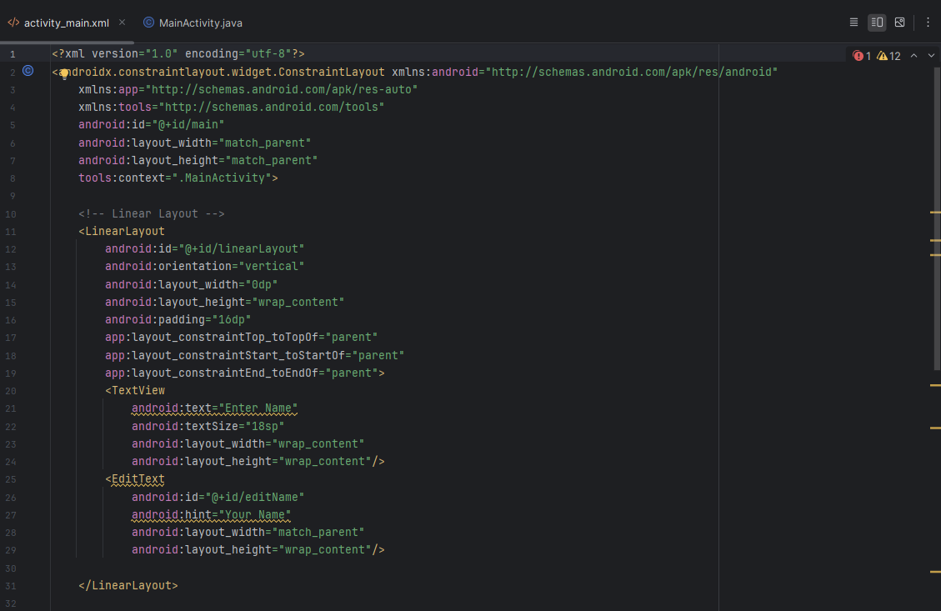
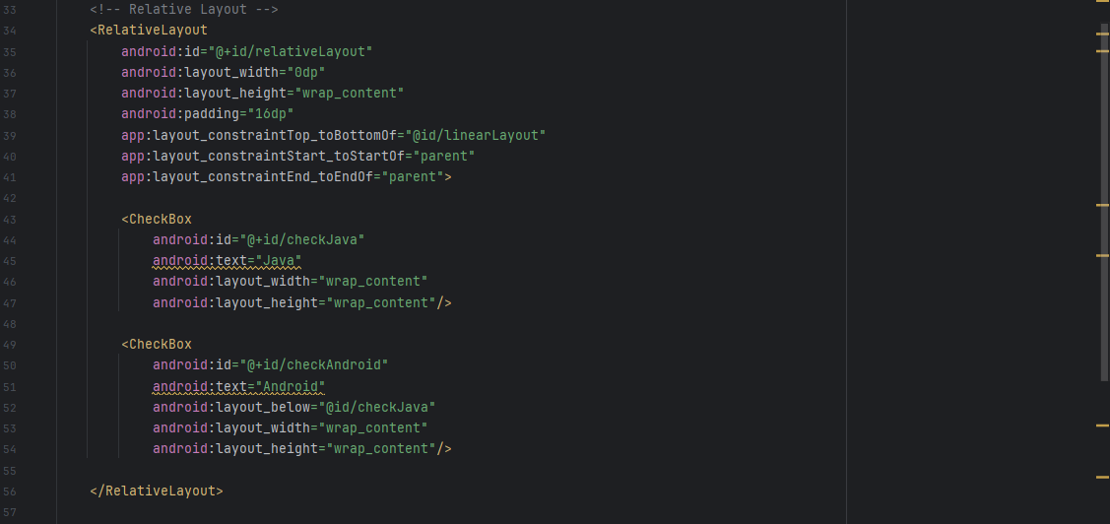
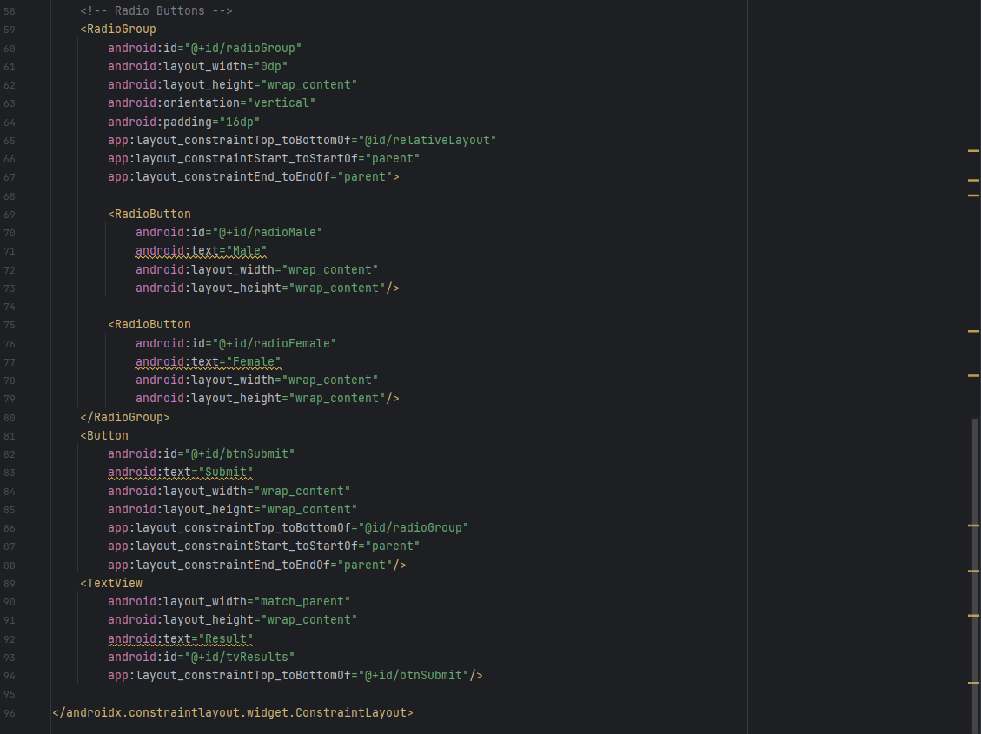

MainActivity.java
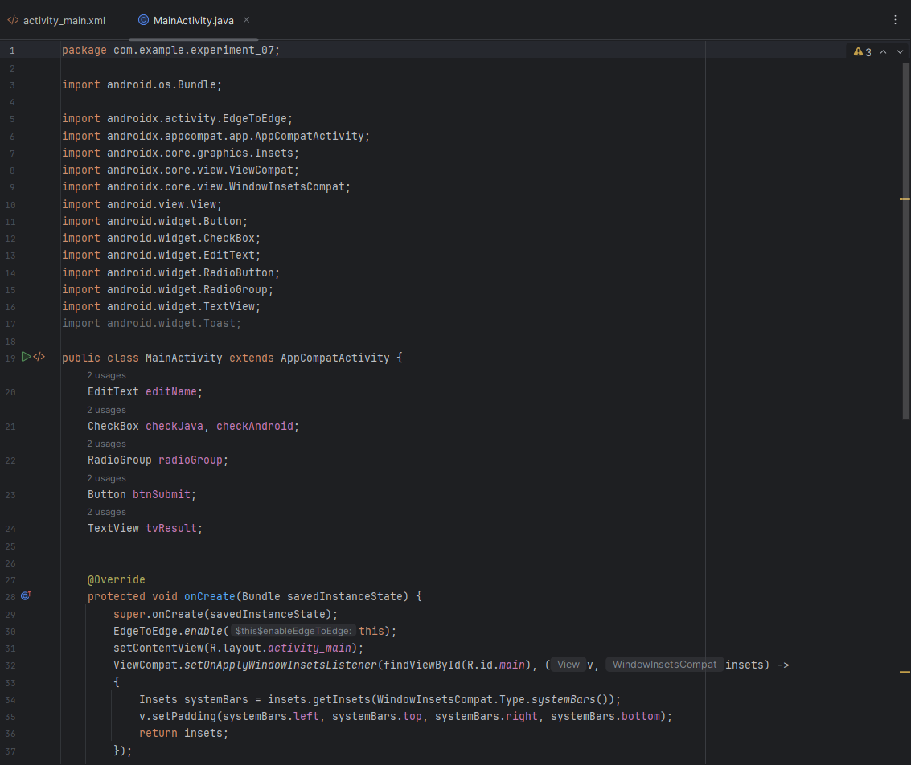
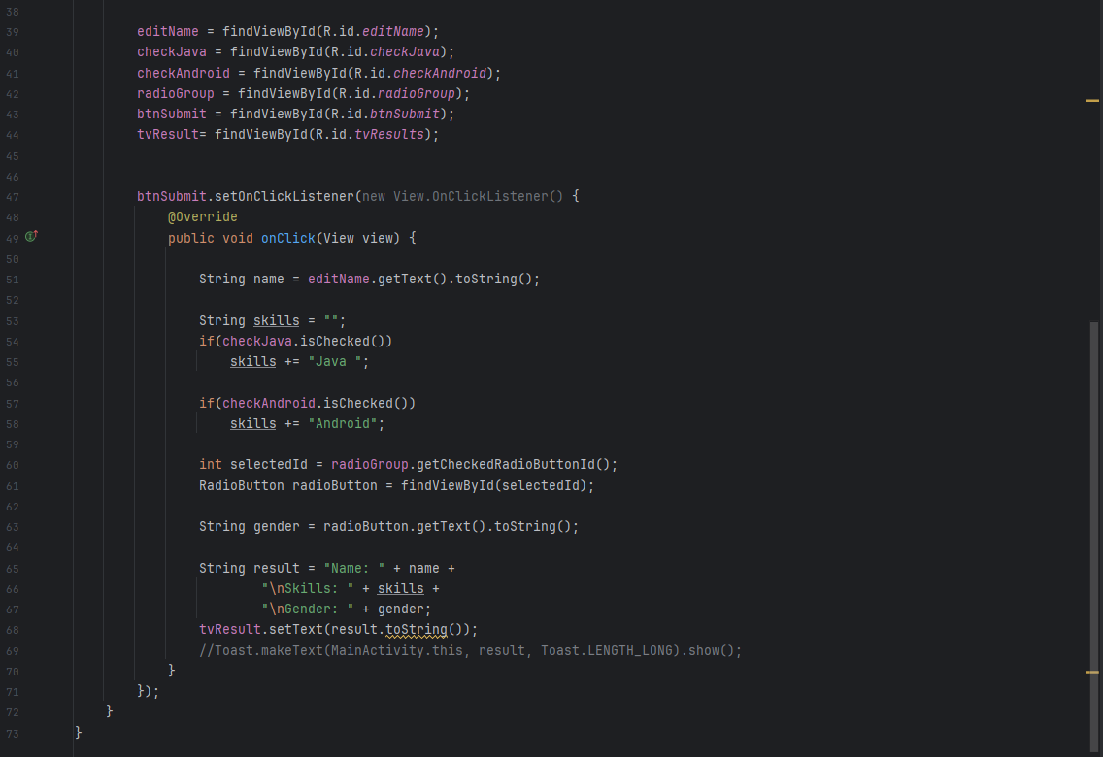

Output:
1. User Input
● User enters name using EditText
2. Multiple Selection
● CheckBoxes allow selecting multiple skills (Java, Android)
3. Single Selection
  - RadioButtons allow selecting one gender option
4. Data Processing
  - App collects all inputs and combines them into a formatted string
5. Display Output
Result is shown in TextView:
Name: XYZ
Skills: Java Android
Gender: Male
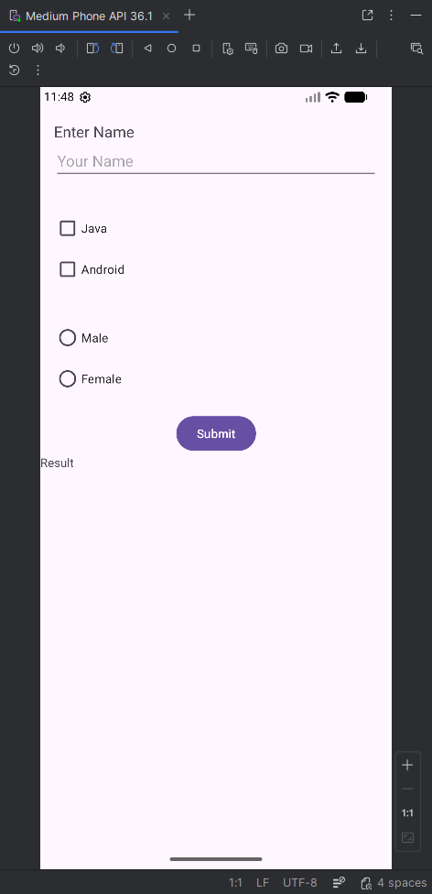 | 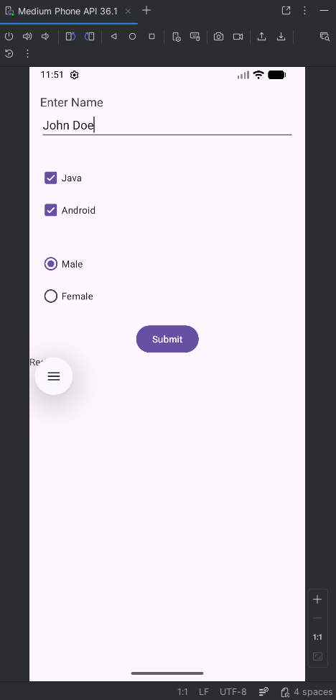 | 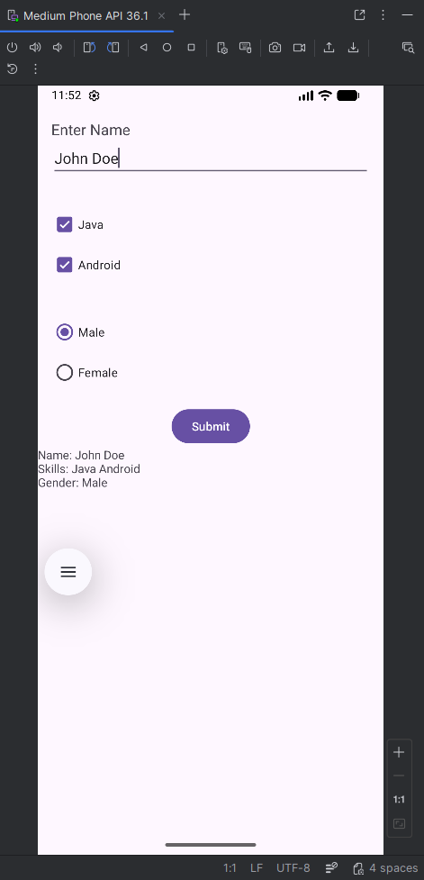

Conclusion:
This practical demonstrates how to use different Android UI components to collect user input, process it, and display dynamic results on the screen.

